Responsibility of Retaining walls SA government

Retaining Walls
A retaining wall is a structure built to retain a difference in ground level. While a retaining wall can serve as the footing for a fence, the wall itself is not considered to be a fence and is covered by different laws. For information about fences, see our Fences and the Law booklet. The law about retaining walls is principally found under thecommon law of nuisance, the Development Act 1993 (SA) and the Development Regulations 2008 (SA).
Before any work in relation to a retaining wall is started, two questions must be answered:
- Is development approval required?
- Must notice be given to the neighbouring land owner?
Development approval
Any excavation or filling of land associated with constructing a building or other structure needs council approval. In these cases, details of the retaining wall for the excavation or fill must be included in the development application for the building or other structure.
When a retaining wall is being built for other purposes, for example, landscaping, or when it is proposed to demolish, remove, repair or alter an existing retaining wall, then development approval from your local council will generally be required.
Approval is not usually needed if the wall retains a difference in ground level of one metre or less (a retaining wall of one metre or less may still need approval if it is in certain zones – check with your local council whether approval is required). Note that it is the overall difference in ground level that is measured - if two or more retaining walls (each less than one metre high) are used together in a tiered fashion, the overall difference in ground level must be less than one metre, otherwise approval will be needed. Note also that, if there is a fence on the wall, approval will be needed if the total height of the retaining wall plus the fence is more than 2.1 metres (measured from the lowest side of the retaining wall).
Notice
If a retaining wall will affect the stability of the neighbour’s land, then the neighbour must be given notice of the proposed work. This is the case even if development approval is not required. Work that is treated as affecting the stability of neighbouring land includes:
- fill within 600 mm of the boundary, unless it is 200mm or less in height and for landscaping type purposes [ reg 75(2)(c) Development Regulations 2008 (SA)]
- an excavation which intersects a notional plane extending downwards at a slope of 1 vertical to 2 horizontal from a point 600 millimetres below natural ground level at a boundary with an adjoining site [reg 75(2)(a) Development Regulations 2008 (SA)] as in the diagram below.
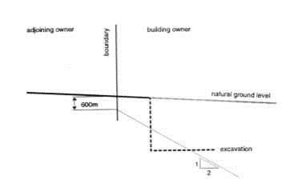
Figure 1. Schedule 15 Development Regulations 2008
What sort of notice is required?
Notice of the intention to perform the work and the nature of that work must be given to the owner of the adjoining land at least 28 days before commencement of the work [s 60 Development Act 1993]. There is no particular form that must be used to give notice, but it is advisable to provide sufficient detail to assure the neighbouring owner that their land will not be affected by the proposed work. If development approval was also required, then providing the neighbour with information from the development application and approval would usually suffice. If development approval was not needed, it may be worth considering obtaining professional engineering advice, which can then be included in the notice.
What can a neighbour do?
If the neighbour has concerns, they may engage a professional engineer to provide a report, along with plans and specifications, on the need to shore up any excavation or to underpin, stabilize or otherwise strengthen the foundations of any building. The person proposing to do the work must comply with the engineer’s advice. They are also required to pay the reasonable costs of obtaining the report, plans and specifications. Payment can be enforced, if necessary, by application to the Environment, Resources and Development Court.
If the neighbour has requested that work be carried out, as specified by a professional engineer, the person building the wall may be able to obtain some payment from the neighbour towards the work, either by negotiation or by application to the Environment Resources and Development Court. This may occur, for example, when the neighbour will obtain some additional benefit from the performance of the work specified by the engineer.
A land owner who has been served a section 60 notice and believes they need more time to obtain engineering advice should, in the first instance and if possible, discuss the matter with the person proposing to do the building work. If more time is not agreed, the land owner may make an application to the Environment, Resources and Development Court to stop commencement of work until necessary engineering advice has been obtained.
What if notice was not given?
A person who performs work that is treated as affecting the stability of neighbouring land without giving notice, or who fails to carry out engineering work required after serving notice, faces a fine of up to $10 000.
If required notice was not given before work was done, a neighbouring owner may, if necessary, apply to the Environment, Resources and Development Court to have further work done to ensure the stability of their land is not affected.
It is not the role of local councils to check or enforce the service of notice in relation to work that may affect the stability of neighbouring land. However, if a local council has received a development application, which includes a retaining wall that does not itself need approval, the council may attach an advisory notice to its approval, reminding the owner that they should provide notice under s 60.
Easements and encumbrances
Before commencing any building work, a further question must be asked: are there any easements orencumbrances noted on the property’s Certificate of Title that could be affected by the proposed retaining wall? If so, and if you need development approval, your application to council must indicate that you have approval to build from the relevant authority or person. If you do not need development approval, you must still obtain the approval of the authority controlling the easement or the person holding the encumbrance before starting work.
Who is responsible to erect a retaining wall?
The most important factor in answering this question is determining the natural state of the land, as land in its natural state needs no support. It is only when the natural land is altered that support is required. Any party can alter the natural state of their land (subject to development controls), but with this ability comes the obligation to support the adjoining natural land.
As a general rule, each owner is responsible for retaining the portion of earth that they (or the previous land owner) have altered from the natural ground level. This could be fill placed on top of the natural ground level or excavation below the natural ground level.
In Pantalone v Alaouie (1989) 18 NSWLR 119, Giles J considered the law of nuisance and found "withdrawal of support from land is an actionable nuisance for which strict liability attaches without proof of negligence."
If a land owner is experiencing loss or damage because their neighbour has altered the natural state of the land, even though their neighbour has a responsibility to support the land, the land owner has an obligation to mitigate (minimise) their damage. If action is not taken to mitigate damage, any claim they may have may be affected.
Rather than each owner building a separate wall to retain what they have filled or excavated, it is usually more practical and economical to build one retaining wall. It is therefore advisable to discuss your plans with your neighbours.
How is apportionment of cost determined?
Where one party fills and the adjoining owner excavates, each party is liable according to the proportion that the retaining wall supports the fill or excavation. For example, if one neighbour fills 300mm above the natural ground and the adjoining neighbour excavates 700 mm below the natural ground, then the neighbour that fills is responsible for 30% of the cost and the neighbour excavating is liable for 70% of the cost of the 1 metre retaining wall.
The cost apportionment that would apply in example 1 below is as follows:
- The retaining wall between A and B: A is responsible for 25% of the cost and B is responsible for 75%.
- The retaining wall between B and C: The cost is shared equally between them as they benefit equally from the retaining wall.
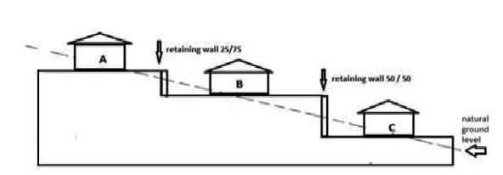
Example 1: apportionment of costs when there are single retaining walls between properties
What happens when there is an existing retaining wall?
There is an existing retaining wall my neighbour has erected, but I want to level (fill) on my property (on the other side of the existing neighbour’s retaining wall).
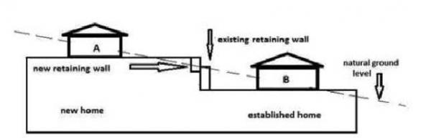
Example 2: existing retaining wall and subsequent fill
The neighbour (A) who proposes to fill (after obtaining development approval and/or giving notice, if required) is responsible for the cost of the retaining wall to hold the fill. Owner A also has an obligation to ensure the existing retaining wall is not overloaded. This may require piers to be sunk below the level of the existing retaining wall to maintain its integrity.
There is an existing retaining wall my neighbour has erected, but I want to level (excavate) on my property (on the other side of the existing neighbour’s retaining wall).
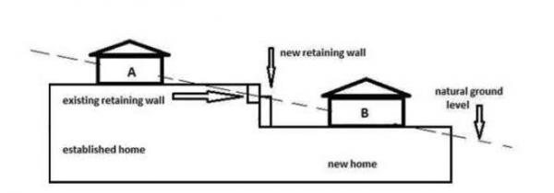
Example 3: existing retaining wall and subsequent excavation
The owner (B) seeking to excavate will be responsible for the cost of the retaining wall to support the excavation they caused and also any costs to ensure that the previous retaining wall erected by the adjoining owner (A) is adequately supported.
However, under the Development Regulations 2008 (SA), the existing fill retaining wall should have been built to allow for some excavation on the adjoining property. If this did not happen and stabilizing work is needed, B may be able to argue that A should contribute to the cost of this work.
Who is responsible to maintain a retaining wall?
Where both parties benefit from the existence of the retaining wall, as in example 1 above, then it is reasonable that both parties will contribute to the maintenance of the retaining wall according to the proportion of the benefit they receive. However, over time and as properties change hands, it can be difficult to know what the gradient of the natural ground level was, who actually altered it, and to what extent. While councils may need to give approval for repairs, it is not the role of councils to determine the proportion of benefit and consequent apportionment of costs.
If the erection of the retaining wall is due to solely to one neighbour affecting the natural state of the land, as in examples 2 and 3 above, then the party affecting the natural state of the land is responsible for repairs and maintenance. That is, each owner (and subsequent owner of that property) is responsible to maintain the wall that benefits them.
The duty to minimise damage
Even if it is the responsibility of one owner to repair a retaining wall, if a neighbour is experiencing loss or damage due to a faulty, deteriorating or damaged retaining wall, that neighbour has an obligation to mitigate their damage, or else any claim may fail.
Do repairs need development approval?
As repairing or altering a retaining wall is classified as development, consideration must be given to whether development approval is needed prior to any work being commenced. Check with your local council. Generally, the principles outlined above under Development approval apply. However, if the repairs are minor, using similar materials and not relating to the stability of the wall, formal approval may not be required.
Boundary issues
When a single wall is proposed
Where it is proposed to build a single retaining wall between properties for the benefit of both land owners, then, if the neighbours agree, the wall can straddle the boundary. Costs are apportioned according to the benefit received.

When there are two walls
If there is no agreement between neighbours, or if there is an existing retaining wall, as in examples 2 and 3 above, then a retaining wall must be built solely on the property of the person required to build the wall. It is not only the visible wall that must be on the builder’s property; the footings must also not go into the neighbour’s property.
When a wall is built on the wrong side of the boundary
If a retaining wall has been built on the wrong side of the boundary (this sometimes occurs, for example, when a developer has built adjoining properties), two issues arise: who is responsible to maintain the wall, and encroachment.
Regardless of which side of the boundary the wall is, the owner receiving the benefit of the wall is responsible for maintaining it. In example 4 below, owner B would be responsible for the wall even if it had been built with boundary position 2 (on the neighbour’s property).
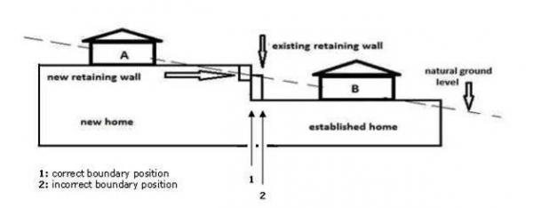
Example 4: correct and incorrect boundary positions
Retaining walls come under the Encroachments Act 1944 (SA), and a retaining wall on the wrong side of the boundary is an encroachment. If the footings of the retaining wall go onto the neighbour’s property, this is also an encroachment. The Act provides for the adjustment of boundaries or compensation where walls encroach on adjoining land. Neighbours may negotiate to resolve the issue. If necessary, an application may be made to the Land and Valuation Division of the Supreme Court.
Walls bordering council land
If the proposed retaining wall is on the boundary of council land, for example, the footpath reserve, then the whole wall, including the footings, must be on your land and not on council property.
Emergency work
The Development Act 1993 (SA) allows for emergency orders to be made if an authorized officer of the local council determines there is a threat to safety arising out of the condition of a retaining wall or an excavation. A local council will usually only consider making an emergency order in extreme cases. Further, if there is any uncertainty about whose responsibility the work is, a council would normally serve notice on both land owners, as it is not the role of councils to decide whose responsibility it is to perform the work.
An order may require the building owner:
- to evacuate the land or building
- not to conduct or allow specified activities
- to stop immediately a specified activity
- to carry out building or other work and
- to prohibit the occupation of a building or land or the use of a building or land.
An owner can appeal the order within 14 days after the order is received by them or longer if granted an extension by the court.
Failure to comply with an emergency order or contravention of an emergency order is an offence, with a maximum penalty of $15 000.
Disputes
The following disputes are dealt with in the Magistrates Court (Minor Civil Action jurisdiction), because they are neighbourhood disputes arising under the common law of nuisance:
- who is responsible to build a retaining wall
- who is responsible for any damage caused by failure to support land after the natural state of the land has been altered
- who is responsible to repair a retaining wall
- apportionment of costs when building or repairing a retaining wall.
Free advice about such disputes may be obtained from the Legal Services Commission or Community Legal Services. Community Mediation is also available in such matters.
Disputes about development applications and s 60 notices are dealt with in the Environment, Resources and Development Court. While initial advice may be obtained from the Legal Services Commission or Community Legal Services, you may need to see a private lawyer about such matters.
The role of councils
Councils cannot:
- resolve disputes about apportionment of costs when building or repairing a retaining wall
- say who is responsible to build or repair a retaining wall.
Councils will not:
- require repairs to retaining walls except in genuinely urgent cases.
The role of councils in relation to retaining walls is:
- to consider applications where development approval is required
- to ensure specifications in applications are to appropriate standards.

